VALIDATE/TFLFT/BBC/146/r1

BBC internal correspondence - not to be
quoted as a reference in published work

March 1998

BBC Research and Development Technical Note R&D 0913 (98)
DTB Document Number 209

DVB-T Receiver performance: measurement of receiver noise floor and definition of difficult channels
C. R. Nokes and J.E. Salter

BBC internal correspondence - not to be
quoted as a reference in published work

March 1998

BBC Research and Development Technical Note R&D 0913 (98)
DTB Document Number 209

DVB-T Receiver performance: measurement of receiver noise floor and definition of difficult channels
C. R. Nokes and J.E. Salter

ABSTRACT
A DTG receiver group seminar on DVB-T receiver performance was held at BBC R&D at Kingswood Warren on Friday 6th February 1998. At this seminar, it was agreed that in addition to front end noise figure, an important parameter in receiver design was the receiver noise floor, Px.
Measurement of receiver noise floor is a difficult challenge. There are no direct methods of measuring the overall value. Nonetheless, Px should still be considered an important parameter. The presentations at the meeting showed that difficult channels do exist which will test the performance of receivers – and an unnecessarily high receiver noise floor will make successful reception in these difficult channels much less likely.
There are two main reasons for measuring Px – firstly it is a single parameter that represents the overall performance impairment that will be suffered by the receiver in difficult receiving conditions. Secondly, by specifying an overall value for Px rather than the individual components, it allows manufacturers the freedom to trade off the different noise sources – for example phase noise and ADC quantising noise.
This document offers some suggestions to the receiver industry as to possible methods for measuring receiver noise floor, and the components of the noise floor. Some of the methods suggested will only be appropriate to limited groups of people (e.g. receiver front end designers), but it is hoped that by offering a number of methods, individuals may choose an approach appropriate to their particular requirements, or as an aid to identifying dominant noise contributions.

DVB-T Receiver performance: measurement of receiver noise floor and definition of difficult channels
C. R. Nokes and J.E. Salter

CONTENTS

1. Introduction 1
2. Brief review of the noise model 1
3. Overview of receiver components of Px 2
3.1 Phase noise 3
3.2 Intermodulation 3
3.3 Thermal noise 3
3.4 ADC quantising noise 3
3.5 DSP noise 3
4. Overview of measurement methods 4
5. Detailed description of measurement methods 4
5.1 Direct measurement of components of Px 4
5.1.1 Phase noise 4
5.1.2 Intermodulation and thermal noise 5
5.1.3 Analogue components of Px 5
5.2 Indirect measurement of effect of Px in difficult channels 6
5.2.1 Rayleigh channel profile from the DVB-T specification 7
5.2.2 Echoes outside the guard interval 8
5.2.3 An ‘artificial’ difficult channel 9
5.3 Substitution method 10
6. References 10

Annexed Figures
Figure A1 Output from domestic receiver showing L(f) over ± 2.5 kHz
Figure A2 Output from domestic receiver showing L(f) over ± 10 kHz
Figure A3 Output from professional receiver with a two tone input
Figure A4 Output from domestic receiver with a two tone input
Figure A5 Output from modified COFDM modulator showing ‘spectrum hole’
Figure A6 Output from test transmitter showing ‘spectrum hole’
Figure A7 Output from professional receiver showing ‘spectrum hole’
Figure A8 Output from domestic receiver showing ‘spectrum hole’

DVB-T Receiver performance: measurement of receiver noise floor and definition of difficult channels
C. R. Nokes and J.E. Salter

Introduction
A DTG receiver group seminar on DVB-T receiver performance was held at BBC R&D at Kingswood Warren on Friday 6th February 1998. At this seminar, it was agreed that in addition to front end noise figure, an important parameter in receiver design was the receiver noise floor, Px (see the notes of the seminar [1] and section 2). Initial impressions from receiver manufacturers were that a value for Px of -33 dBc was sensibly achievable, however there were no suggestions about how this parameter could be measured – it was left as an action of the meeting for the BBC to suggest some possibilities for measurement methods.
It should be stressed that measurement of Px is a difficult challenge. There are no direct methods of measuring the overall value. Nonetheless, Px should still be considered an important parameter. The presentations at the meeting showed that difficult channels do exist which will test the performance of receivers – and an unnecessarily high receiver noise floor will make successful reception in these difficult channels much less likely. A document presented at the seminar [2] gives a simple noise model for a receiver and shows the effect of receiver noise floor on performance in difficult channels.
There are two main reasons for measuring Px – firstly it is a single parameter that represents the overall performance impairment that will be suffered by the receiver in difficult receiving conditions. Secondly, by specifying an overall value for Px rather than the individual components, it allows manufacturers the freedom to trade off the different noise sources – for example phase noise and ADC quantising noise.
This document aims to offer some suggestions to the receiver industry as to possible methods for measuring Px. Some of the methods suggested will only be appropriate to limited groups of people (e.g. receiver front end designers), but it is hoped that by offering a number of methods, individuals may choose an approach appropriate to their particular requirements.

Brief review of the noise model
Reference [2] gives a detailed description of the noise model, but it is worth summarising the model here for completeness.
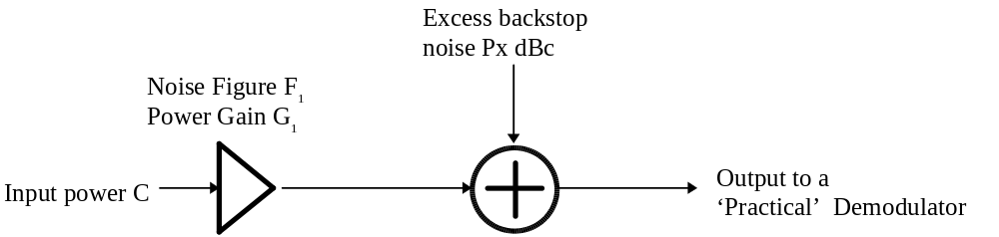
Figure 1 Noise model

The model is shown in Figure 1. The noise model has two stages. Stage 1 represents degradations which are dependent upon carrier level such as the receiver noise figure F₁. Stage 2 represents degradations which are independent of carrier level such as: the intercarrier interference component of phase noise, ADC quantising noise and transmitter intermodulation products. These degradations are best expressed in terms of an excess noise source, or backstop noise, Px.
At the DTG receiver group meeting mentioned above, the following values were agreed as receiver design targets.
- The noise figure of the tuner F1 to be better than 7dB for band IV and 8dB band V, for 80% of production.
- There is a need to define a maximum limit although this may be difficult to reach agreement on.
- Excess noise (backstop noise, or noise floor, Px): –33 dBc
- A necessary (but perhaps not sufficient) criterion for adequate performance would be to achieve the following protection ratios for a bit error ratio of 2x10⁻⁴ after Viterbi, in the presence of transmitter noise at –34 dBc:

Unwanted signal | Interferer characteristics | Level relative to wanted carrier
Co Channel interference | PAL-I, 75% colour bars, FM sound: 1 kHz tone, NICAM | -4dB
Adjacent Channel | PAL-I, 75% colour bars, FM sound: 1 kHz tone, NICAM | +35dB
Gaussian Noise |  | -20dB
`Typical` Multipath channel |  | -23dB
Echo inside the guard band |  | -8dB
Echo outside the guard band |  | -25dB
Note: most of these conditions are taken from the ITC/NTL/BBC Joint Planning study, which assumed a noise figure of 5 dB

Overview of receiver components of Px

The main components that contribute to the receiver noise floor Px are listed below. This list is by no means definitive. Noise tends to appear from unexpected places such as broadband noise in AGC circuitry or electromagnetic interference. It should be borne in mind that there are no mechanisms which remove random noise ⎯ they all add!

Phase noise
When the COFDM signal is heterodyned, any phase noise sidebands on the local oscillator will be transferred to each carrier of the COFDM ensemble. The phase noise sidebands associated with any one carrier will extend beyond the carrier spacing and thus degrade other carriers of the ensemble by causing intercarrier interference. The total degradation to the ensemble can be calculated by summing (integrating) this effect over all carriers Reference [3].
It should be noted that some of the effects of low frequency phase noise which is common to all carriers can be reduced within the demodulator by the actions of the demodulator algorithms – automatic frequency correction (AFC), channel equalisation and common phase error (CPE) correction.

Intermodulation
Non-linearity within any stage will cause the generation of additional signals such as harmonics, third-order intermodulation products and cross-modulation sidebands. Additional signals which fall outside of the ensemble bandwidth can be removed by filtering. Additional signals which fall inside the ensemble bandwidth will contribute to the noise floor. These effects can be minimised if signal levels are kept low relative to the signal handling capability of the stage.

Thermal noise
All stages within the signal path will contribute their own noise. This can be minimised if signal levels are kept high relative to the stage noise. Note, this is in direct conflict to the requirements to minimise the effects due to non-linearity.

ADC quantising noise
This will arise as a direct consequence of the finite resolution of the conversion process. However, there are design factors which may result in the ideal finite resolution not being achieved. For example, a practical 8 bit ADC design may only achieve a performance equivalent to an ideal 6 bit ADC.

DSP noise
The calculations performed throughout the digital signal processing (DSP) will be with numbers of finite word length. The results of calculations with these numbers will be subject to rounding and truncation which will result in small errors. This may have the effect of additive or multiplicative noise.

Overview of measurement methods
Three categories of measurement method are proposed, each with its own advantages and disadvantages. These are summarised in Table 1.
Table 1 Summary of advantages and disadvantages methods of measurement of Px
Measurement method | Advantages | Disadvantages
Direct measurement of components of Px | Gives accurate measurement of the components of Px, allowing design improvements to be made where appropriate. | Individual components cannot easily be measured non-intrusively.  Components of Px arising from the demodulator chip cannot be measured  Components may be missed
Indirect measurement of effect of Px in difficult channels | Gives an overall measure of Px  Measures Px in the conditions under which the receiver will have to work  It measures the Px the demodulator chip will actually ‘see’ | It will be difficult to obtain cross-industry agreement on a single yet appropriate difficult channel  Limitations in demodulator algorithms will affect performance in difficult channels and may mask the true value of Px
Substitution method | Gives the best measurement of the overall value of Px | May not be appropriate for all demodulator chips

Detailed description of measurement methods

Direct measurement of components of Px

Phase noise
A single tone from a ‘quiet’ signal generator at the channel centre frequency is applied, at a level of about -60 dBm, to the receiver input. The phase noise of the ‘baseband’ signal at the input to the ADC is measured with a ‘quiet’ spectrum analyser. Note: the measurement of Gaussian noise with a spectrum analyser is quite complex [Reference 4]. If only a bandwidth correction is applied then the absolute error is probably less than 1.5 dB. Alternatively, if the ‘baseband’ signal is not available then an IF signal would suffice, because the majority of the phase noise degradation will probably be due to heterodyning the UHF signal. Typical results are shown in Figures A1,A2. Typically two measurements are made: L(f) @ 1 kHz which is within the synthesiser loop bandwidth, and L(f) @ 10 kHz which is outside the synthesiser loop bandwidth. From the shape of the phase noise spectrum an assessment can be made of the integrated phase noise component that causes intercarrier interference.
This measurement method has insufficient dynamic range to measure the oscillator phase noise floor. However, an assessment can be made to see if this will cause reciprocal mixing problems from, for example, an adjacent PAL-I vision carrier. With the single tone applied as above, the noise floor over the range ± 3.8 MHz is viewed. A second tone is added at the receiver input, at a frequency of + 5.25 MHz and amplitude + 35 dB relative to the first tone. An increase in noise floor may be observed. This could be due to reciprocal mixing or the action of a wideband RF AGC circuit.

Intermodulation and thermal noise
Two tones with a frequency difference of about 1 MHz and within the channel are applied, at a level of about -50 dBm, to the receiver input. It is important that this input signal is free from intermodulation products produced by combining the signal generators. If the two signal generators are each reduced in level with external attenuators of at least 30 dB before summing, then sufficient isolation should be achieved (see Figure 2). The spectrum of the ‘baseband’ signal at the input to the ADC is measured with a spectrum analyser with good dynamic range. Typical results are shown in Figures A3,A4. Note: analyser corrections for Gaussian noise in 7.61 MHz bandwidth have to be applied [References 5,6]. The action of the receiver AGC may mean that a small correction may have to be applied, because of the different peak-to-mean ratio of this signal compared to a COFDM signal. Two-tone testing is one of the most powerful and simplest tests available to the analogue designer.
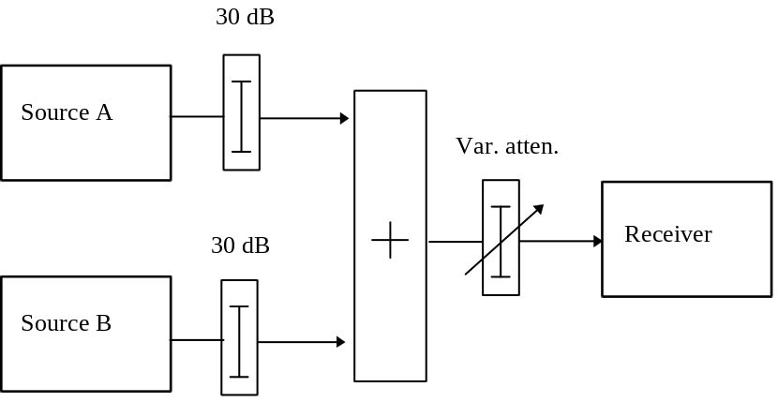
Figure 2 Block diagram showing method of summing tone sources

Analogue components of Px
This method measures the sum of: ICI component of phase noise, intermodulation, and thermal noise. A COFDM modulator is modified so that a number of carriers within the ensemble are removed, thus forming an in-band spectrum hole. This hole however has finite depth due to the phase transitions of nearby carriers producing (sin x)/x spectral components. A simple notch filter can increase the depth of this hole to typically -50 dBc. This is shown in Figure A5. There may be other ways of reducing the (sin x)/x spectral components such as digital filtering or controlling the phase transitions of nearby carriers, or just making the hole wider. The only consideration for the receiver is whether there is any significant alteration in the peak-to-mean ratio of the signal. The small decrease in mean level is accommodated by the receiver AGC. Once a reasonably deep spectrum hole is established, the baseband signal from the modulator is frequency converted to a UHF channel. This process will introduce some excess noise and the depth of the spectrum hole will start to fill. The depth of the hole at the output of the test transmitter may be typically -45 dBc. This is shown in Figure A6. This should be adequate to measure excess noise contributions within a receiver as low as -35 dBc, with 0.5 dB accuracy. Lower noise floors may be measured but a correction factor is required to improve the accuracy, see for example Figure 3.
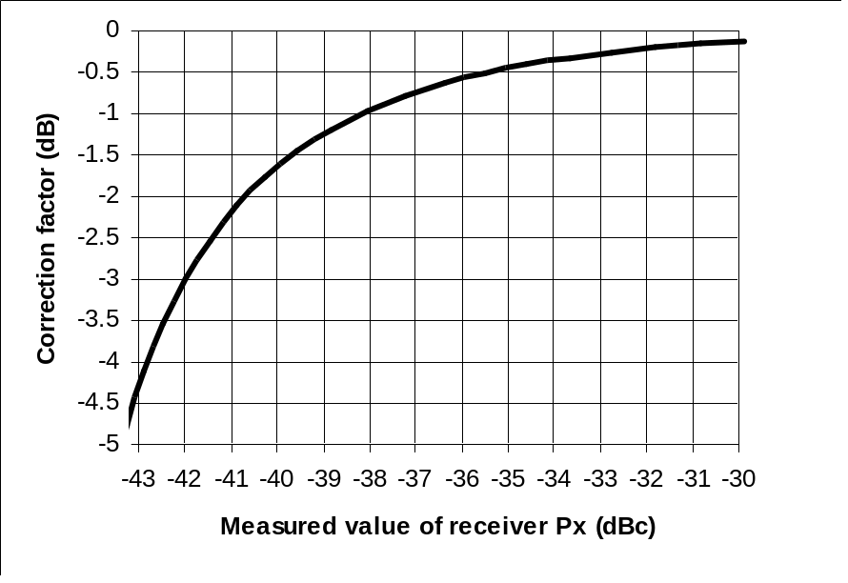
Figure 3 Measurement correction factor with a test transmitter Px of -45 dBc
This modified COFDM signal from the test transmitter is applied, at a level of about -50 dBm, to the receiver input. The spectrum of the ‘baseband’ signal at the input to the ADC is measured with a spectrum analyser with a good dynamic range. Typical results are shown in Figures A7,A8.

Indirect measurement of effect of Px in difficult channels
Since the only reason for being concerned about the value of Px is to be confident that receivers will work in the difficult channels which will exist in areas which are nevertheless served according to the coverage maps, it would seem to make sense to attempt to measure the performance of the receiver by testing it in a channel which should be just difficult enough to prevent the receiver from working – or perhaps by defining a difficult channel in which receivers would be expected to work.
Three difficult channels are suggested, and these are described in the following sections

Rayleigh channel profile from the DVB-T specification
The DVB-T specification [3] includes typical channel profiles for fixed reception “Ricean” profile and for portable reception “Rayleigh” profile. A receiver which is intended to be operated with a set-top antenna (in areas where there is sufficient field strength) should therefore work with this channel profile, although there may be a significant loss of noise margin compared to the Gaussian channel ([7-10] dB maximum for 64-QAM convolutional code rate 2/3). A good test of receiver performance is to measure the loss of noise margin for all code rates (1/2, 2/3, 3/4, 5/6, 7/8). As the code rate is increased, so the expected loss of noise margin will increase (see the figures given in the specification). A receiver with a noise floor above or worse than the required C/N for a given code rate will not be able to operate at that code rate with this channel profile.
VALIDATE has defined a channel profile for modem tests which takes the 6 strongest rays of the “Rayleigh” profile from the specification, since many channel simulators are unable to simulate more than six rays. It is recommended that this subset be used as a standard receiver test in the UK. The channel profile is:

Delay (µs) | Relative Attenuation (dB)
0 | 2.8
0.05 | 0
0.4 | 3.8
1.45 | 0.1
2.3 | 2.6
2.8 | 1.3

and the expected loss of noise margin is as follows, for each convolutional code rate in 64-QAM:

Code rate | Loss of noise margin compared to a Gaussian channel (dB)
1/2 | [1.6]
2/3 | [2.8]
3/4 | [3.7]
5/6 | [6.0]
7/8 | [7.8]

The figures quoted above are the total loss of noise margin assuming a system with a low noise floor is used. In a system with a noise floor which is to be estimated, the actual loss of noise margin can be measured and this will be greater than the figures above.
Note that care is required when measuring loss of noise margin for this channel. Since the channel response is very uneven, the carrier power entering the receiver is increased compared to the flat channel condition. If C₀ is the carrier power with no echoes, and N₀ is the noise power that must be added for QEF in a Gaussian channel, then C₀/N₀ is the Gaussian C/N requirement. With the echoes switched on, the carrier power must be re-measured. If the carrier power with echoes is C₁, and the corresponding noise power for QEF is N₁, then the measured loss of noise margin is C₁/N₁ – C₀/N₀. An approximate conversion from measured loss of noise margin could be given by a series of curves, an example of which is given in Figure 4

Echoes outside the guard interval
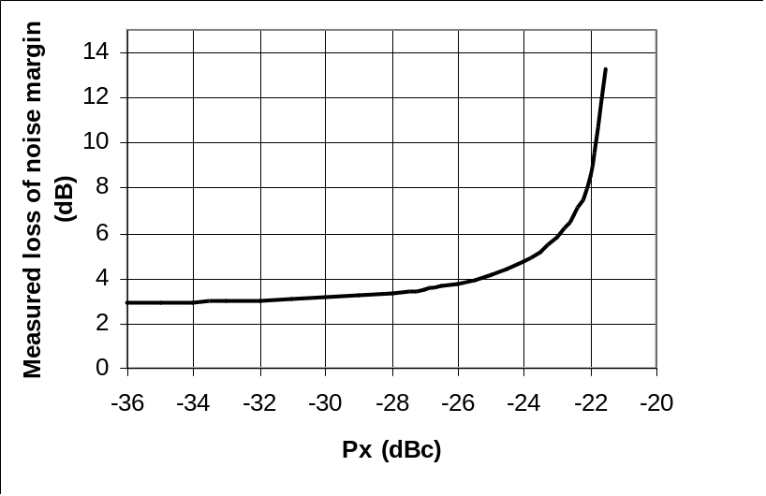
Figure 4 Curve to convert measured loss of noise margin to Px. Assumes a C/N requirement of 18.5 dB for a Gaussian channel, and a loss of noise margin for the Rayleigh channel of 2.8dB for small Px.
The BBC has found a number of sites where significant echoes a long way outside the guard interval are a cause of increased C/N requirement. One of these channels therefore makes a very good test of receiver performance, but does not directly measure Px. A typical difficult channel profile might be:
Delay (µs) | Relative Attenuation (dB)
0 | 0
18 | 20
59 | 20
64 | 28
75 | 25

An ‘artificial’ difficult channel
A method of generating an artificial difficult channel is being developed [7], and is showing promise in simulations and initial laboratory tests. This has the advantage that it should be relatively independent of demodulator chip design, but of course has the disadvantage of not reflecting any real receiving conditions. It should allow a reasonable measure of Px, within the range of interest.
The artificial difficult channel is formed by modifying a DVB-T modulator. Deliberate errors are inserted immediately after the convolutional encoder (before puncturing), by setting 1 bit in [69] to be always a ‘1’. Thus a valid, but incorrect, constellation point is transmitted, fooling the receiver’s Viterbi decoder into assigning inappropriately high confidence to the received value. This badly affects the performance of the receiver, but in a random way, which should be independent of demodulator design. This allows the value of Px to be gauged, by measuring the required carrier to noise ratio with and without this modification to the modulator. An example curve as shown in Figure 5 could be used to estimate Px.
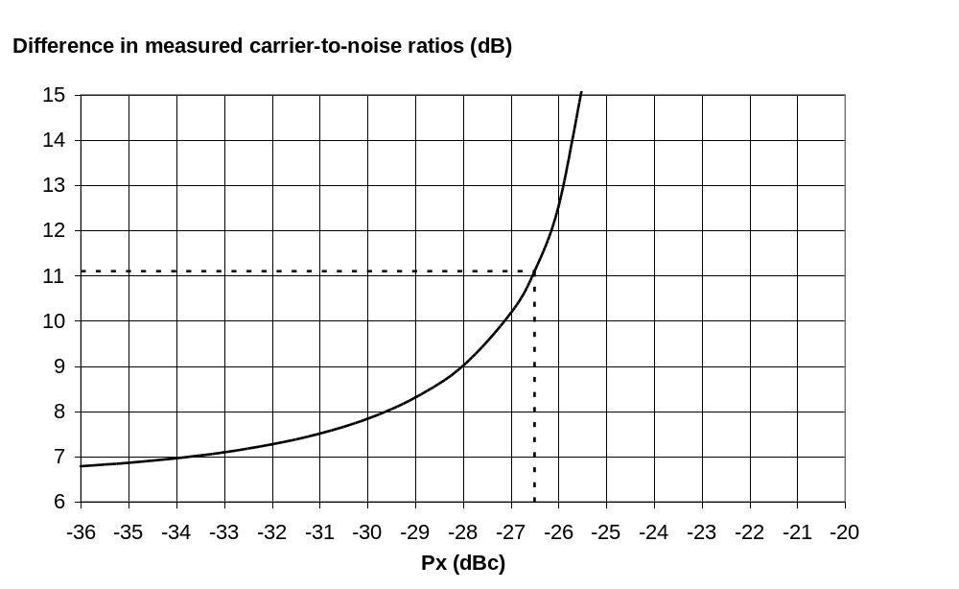
Figure 5 Curve used to estimate Px from measured difference in carrier to noise ratio, assuming the required carrier to noise ratio for a low noise floor system with an unmodified modulator is 18.5 dB and for the modified modulator it is 25 dB. The dotted lines show an example measurement, where the difference in measured carrier to noise ratio was actually 11.1 dB. This implies that the noise floor for the system under test is -26.5 dBc.

This novel measurement method would involve the use of a test modulator which had been modified to operate in this way. Tests of this method are currently being conducted, and results will be published in due course.

Substitution method
This method relies on the ability of some demodulators (e.g. the BBC demodulator, and the LSI Logic chip L64780) to give an accurate indication of the received level of C/(N+I) by their indication of “channel state information” (CSI).
One method that requires a front-end with a low level of Px (i.e. a reference front-end) is as follows:
The front end to be measured (tuner plus ADC) is connected to the demodulator and the CSI display is observed. The mean level of the CSI is noted. The front end is then replaced by the higher quality front end (either a low-phase-noise down-converter, or perhaps a direct analogue baseband connection to a modulator, together with a high quality 12-bit ADC) and the CSI display observed again. The mean level should now be significantly lower. Noise is now injected into the analogue path, and the level increased until the CSI display returns the former level. The ratio of the wanted signal level to the added noise can now be measured, and is the required value of Px.

Alternatively, the above could be done once with a range of noise level as a calibration process or calibrated chips may become available from the supplier. Subsequent measurements of Px could then be done just by observing the CSI level.

References
- Notes of COFDM Meeting 6 February 1998, at Kingswood Warren. Memo from Andrew Bolton, BDB.
- Salter, J.E. Noise in a DVB-T system. BBC R&D Technical Note No. R&D 0873(98). February 1998.
- Stott, J.H. The effects of phase noise in COFDM. Submitted for publication to the EBU Technical Review. BBC R&D Technical Note No. R&D 0869P(98). January 1998.
- Hewlett-Packard Application Note 246-2. “Measuring Phase Noise with a Spectrum Analyzer”
- Hewlett-Packard Application Note 150-4. “Spectrum Analysis: Noise Measurements”
- Johnson K. “Use spectrum analyzers’ selectivity to precisely measure random noise” EDN March 1992
- Nokes, C.R. “Apparatus and method for testing digital modulation systems”. UK patent application No. 98 04248.4
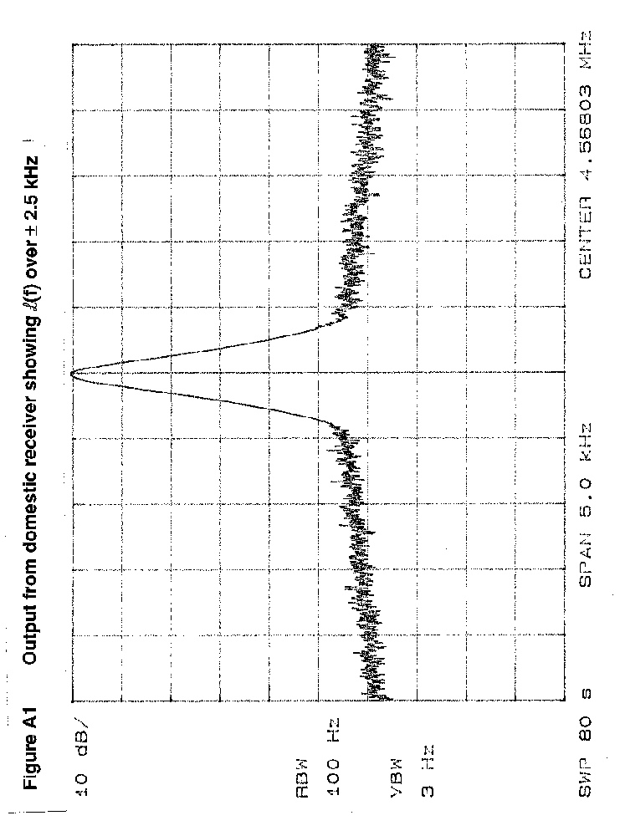
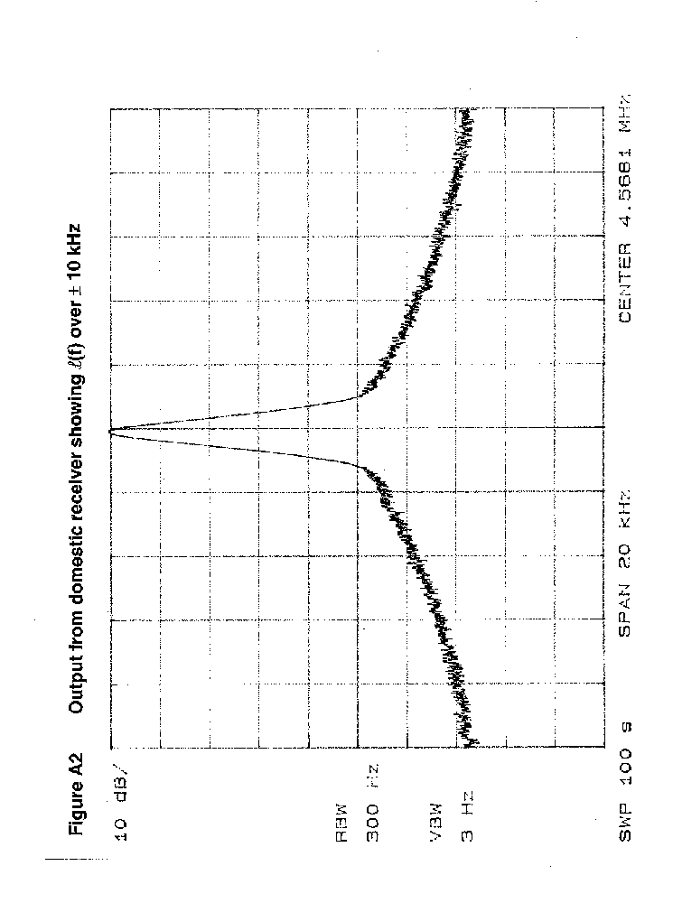
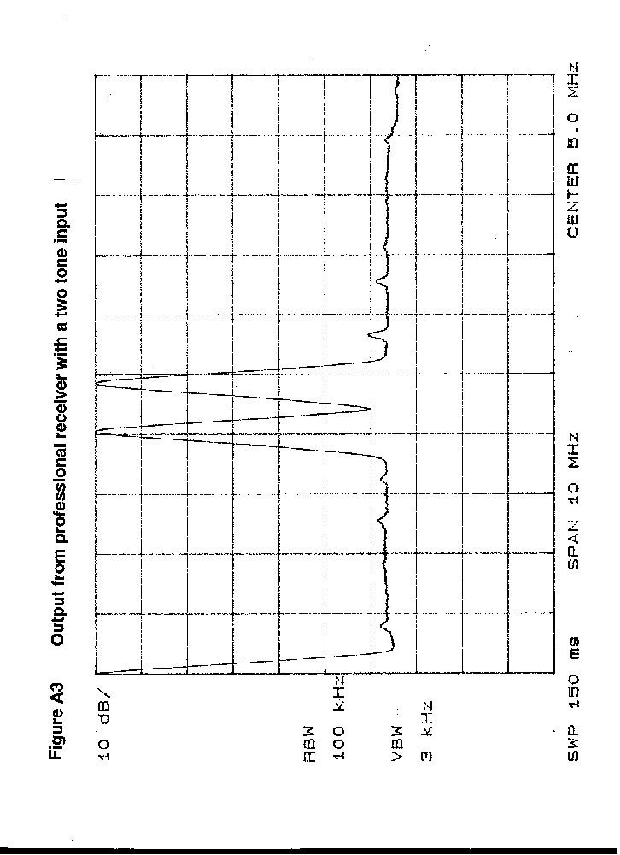
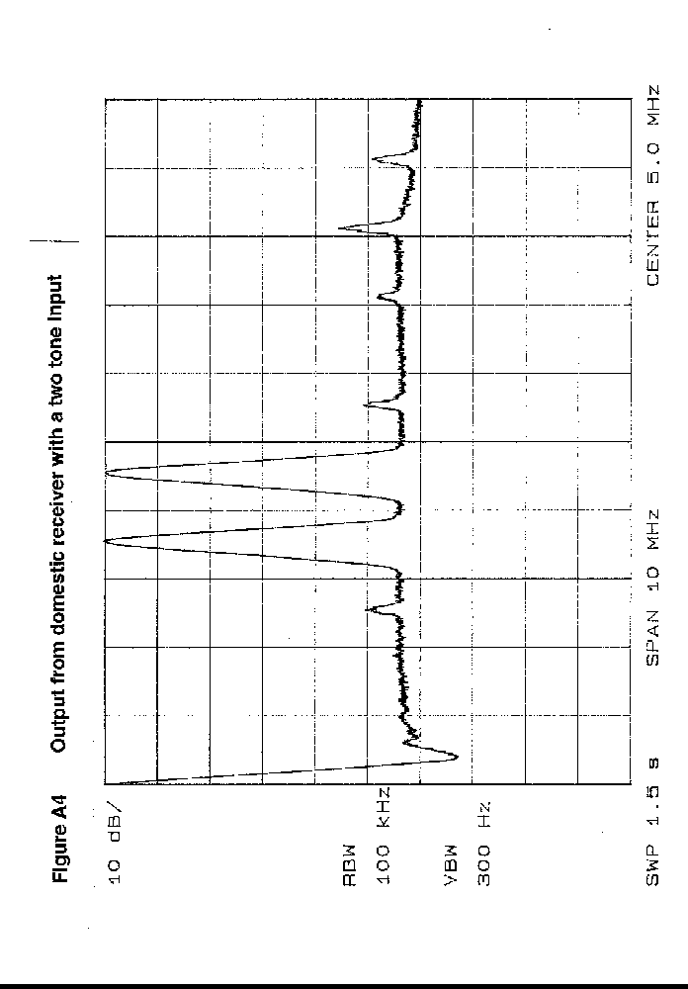
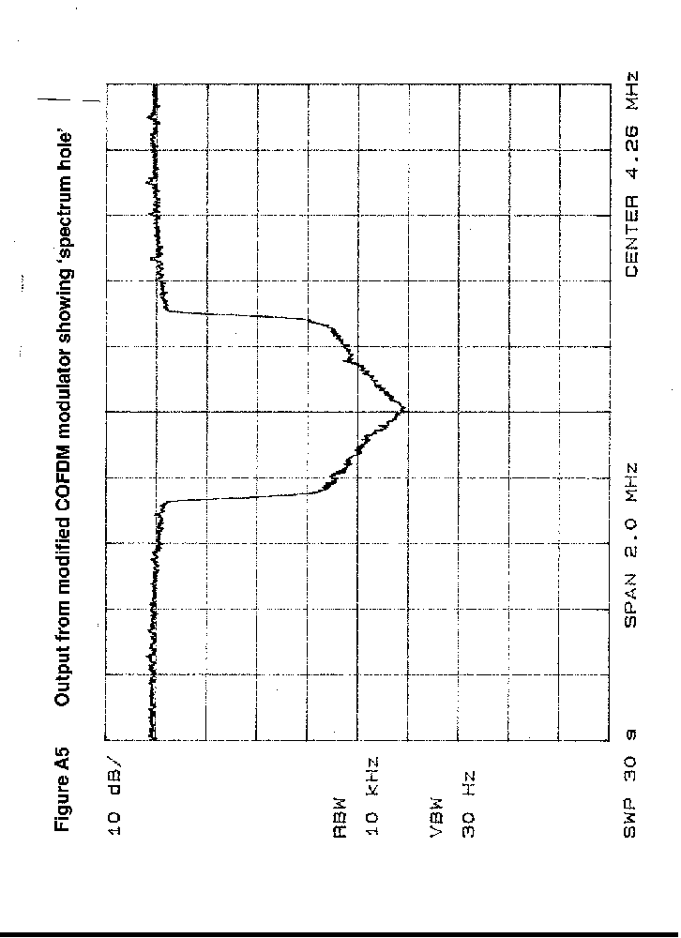
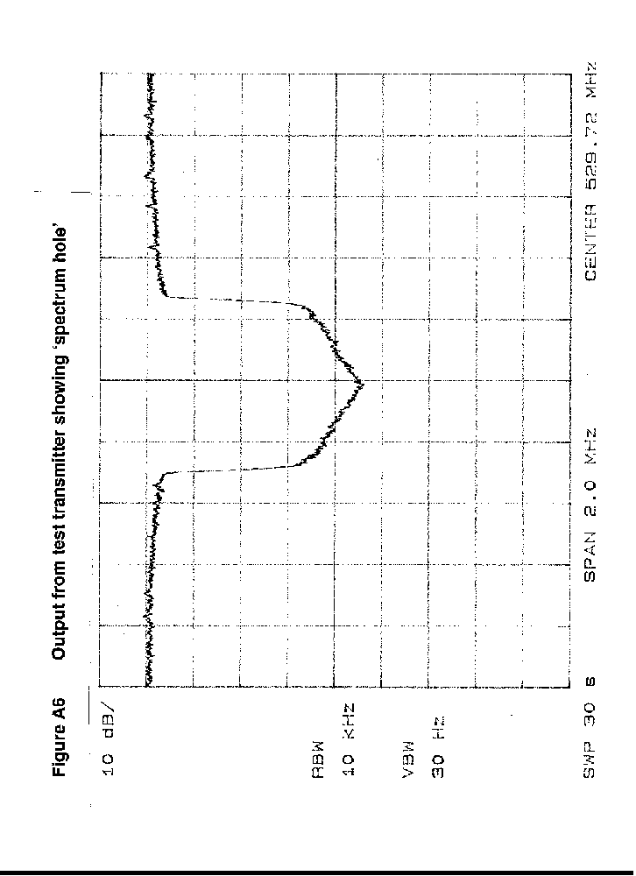
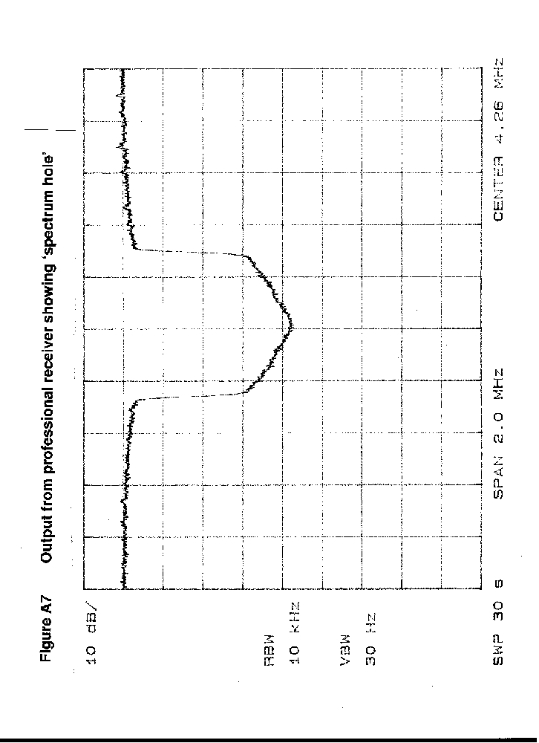
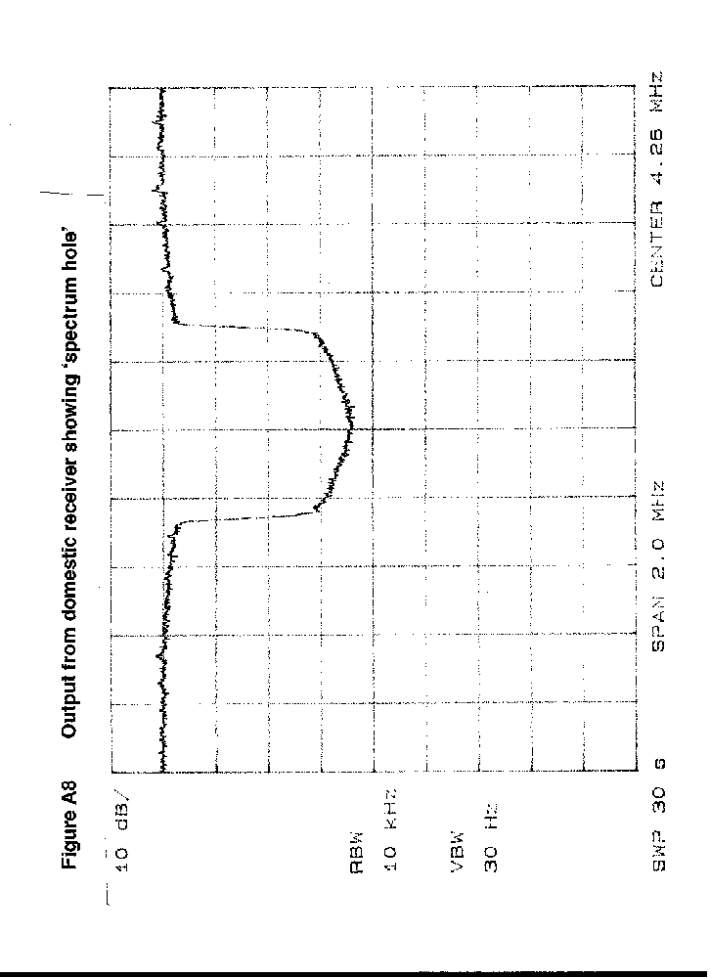

‘Quiet’ means phase noise characteristics are negligible compared to the receiver.
The usual checks should be made to ensure IP and noise measurements are not limited by the analyzer
These figures are only estimates and need to be verified
These figures are taken directly from the specification and need to be verified.
The best value has still to be verified

